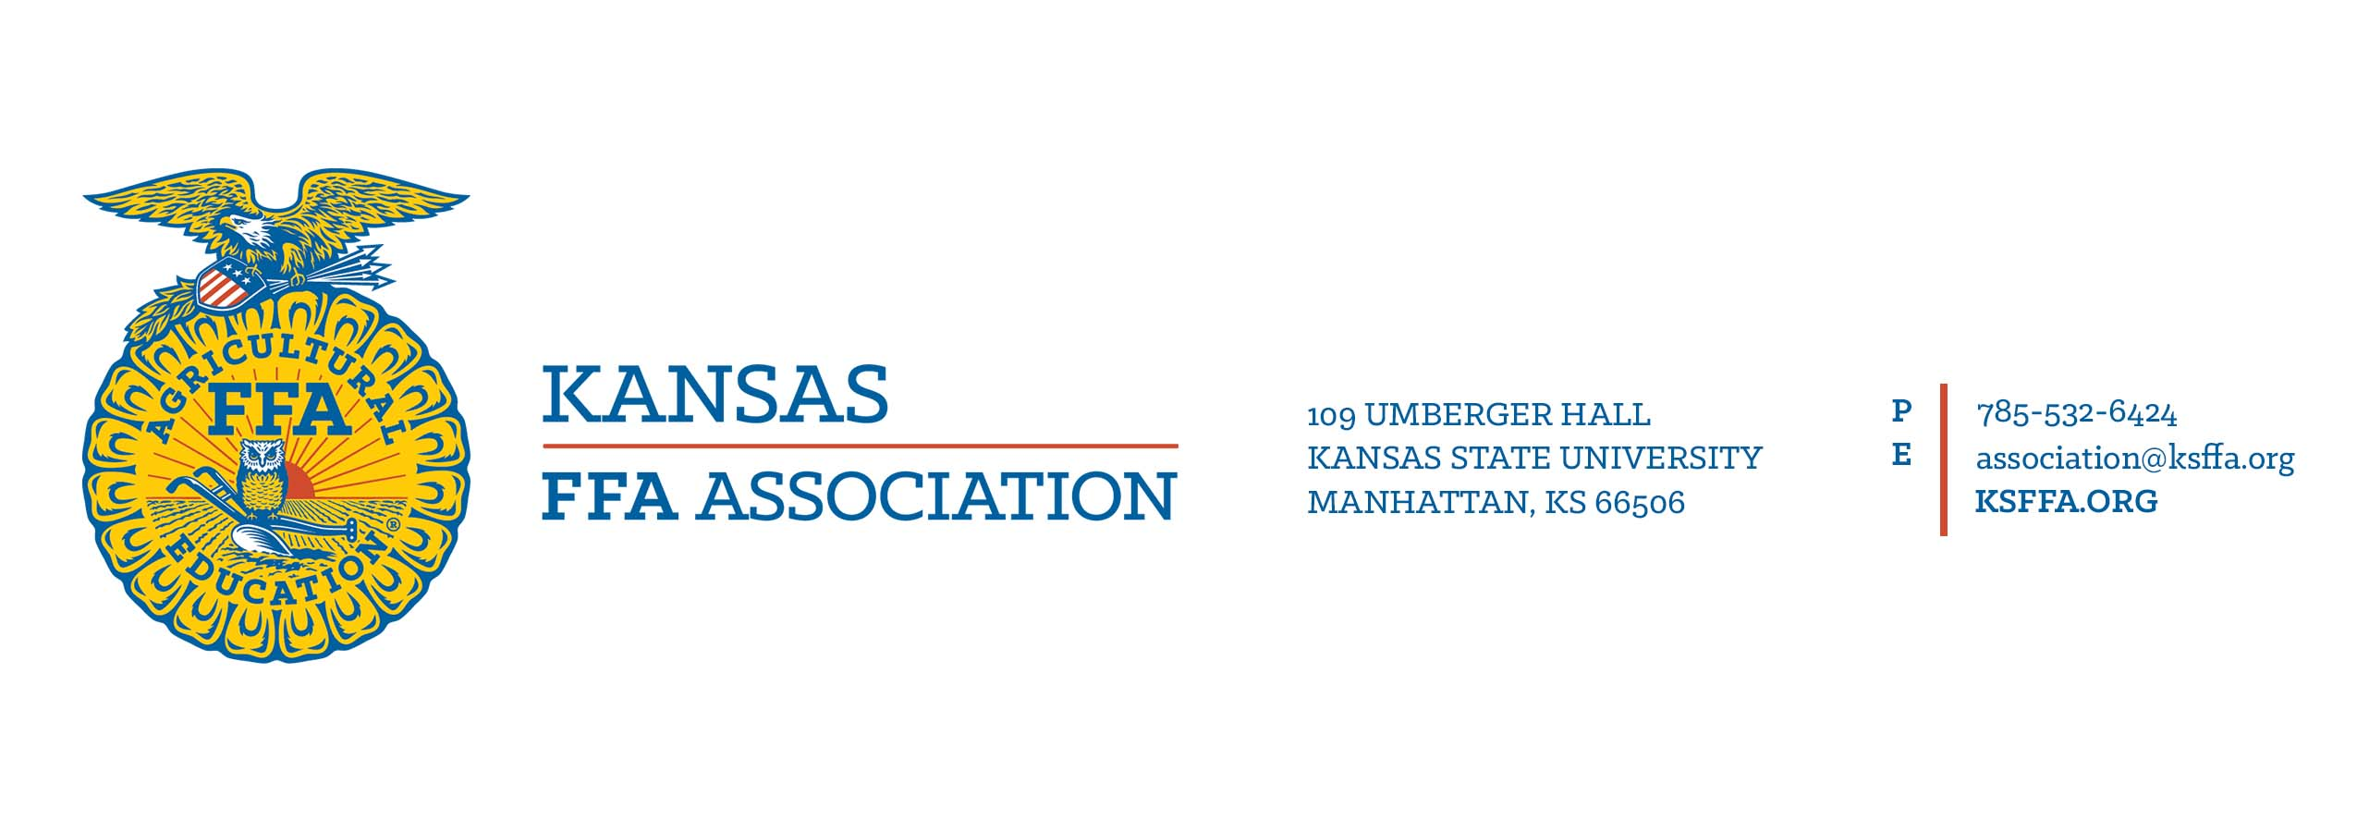

*Updated 7/2021

Prepared Public Speaking
Event Rules
- The Kansas FFA State Prepared Public Speaking Leadership Development Event will be limited to five participants from each district.
- Any member may participate if they: (a) are currently enrolled in agricultural education; and (b) have not placed first in the state competition previously.
- No objects may be used during the speech for demonstrative purposes.
- The National Prepared Public Speaking Rubric and Score Card will be used in the state competition.
- Preliminary Prepared Event will be held at the same time as the Preliminary Extemporaneous Event during the State FFA Convention.
- Each participant's manuscript will be the result of his/her own efforts. It's expected that the participant will take advantage of all available training facilities at his/her local school in developing his/her speaking ability. Facts and working data may be secured from any source but must be appropriately documented.
- It is highly recommended that participants be in official FFA dress as defined in the current Official FFA Manual.
Event Format
- Manuscripts
Manuscripts are to be uploaded in PDF format by the designated deadline on KSFFA.org. Upload instructions are on KSFFA.org. A penalty of 20 points (10 percent of available manuscript points) will be assessed by the judges scoring the manuscripts for any late submissions. Manuscripts received later than the second Friday in May will not be entered into the event, and the speaker may be disqualified from speaking in the event.
Manuscript requirements
- Formatted to fit 8 1/2 x 11-inch paper double spaced with a 1-inch margin
- Cover page including the speech title, participant’s name, state and year
- Font size must be 12 point using a serif (Times New Roman, Cambria, etc.) or sans serif font (Ariel, Calibri, etc.)
- Follow the most current APA style guide for developing a reference list and in-text citations.
- Manuscripts not meeting these guidelines will be penalized.

A complete and accurate reference list should be included in the manuscript. To avoid plagiarism, all participants in the Kansas FFA Prepared Public Speaking Leadership Development Event should give credit to others where any direct quotes, phrases or special dates are used in the manuscript.
- Subjects
Participants may choose any current subject of an agricultural nature for their speeches. This may include the areas of agribusiness, animal systems, plant systems, environmental services, food products and processing, natural resource systems, biotechnology systems and power, structural and technical systems.

Official judges shall disqualify a participant if he or she speaks on a non-agricultural subject.
- Time Limit
Each speech will be a minimum of six minutes in length and a maximum of eight minutes. Participants will be penalized one point per second on each judge’s score sheet for being under six minutes or over eight minutes. Each participant will be allowed five additional minutes in which he or she will be asked questions relating to his or her speech and/or manuscript content. No time warnings will be given.
- Scoring
- Prior to the event, the content and composition of all manuscripts will be judged and scored by qualified individuals using the manuscript rubric. Manuscript scores will be averaged and supplied to the presentation judges after they have scored the oral presentation. The average manuscript score along with manuscript comments will be presented to the participants following the announcement of the winners.
- Presentation judges will be furnished with typewritten copies of the participants’ manuscripts, which they will use to formulate questions. Questions shall pertain directly to the speaker’s subject. Questions containing two or more parts should be avoided.
- Event officials will randomly determine the speaking order and ensure that prior to giving the speech, each speaker is properly introduced. A participant will be permitted to use notes while speaking, but deductions in scoring may be made for this practice if it detracts from the effectiveness of the presentation. No props are to be used. Applause shall be withheld until all participants have spoken.
- A designated timekeeper will record the time used by each participant in delivering his or her speech, noting under time or overtime, if any, for which deductions will be made.
- At the time of the event, each judge, without the collaboration with others, will use the official rubric to score each participant on the delivery of the speech. They will also complete a judge’s comment card which will be presented to the participant following the announcement of the winners.
- Each judge will ask questions at the conclusion of the oral presentation of the speech. Judges will score each participant on the ability to answer all questions asked by judges. The full five minutes for questions should be used.
- When all participants have finished speaking, each judge will total the score on composition, delivery, and response to questions for each participant. The timekeeper(s) record will be used in computing the final score after the presentation and response to questions have been scored. Again, each judge without collaboration with others will rank participants based on the scores. The judges’ score sheets will then be submitted to event officials to determine final ratings of participants.
- The judges’ ranking of each participant then shall be added, and the winner will be that participant whose total ranking is the lowest. Other placings will be determined in the same manner (low rank method of selection).
Activities | Points
Manuscript | 200
Presentation | 500
Response to questions | 300
TOTAL POINTS | 1,000

- Tiebreakers
Ties will be broken based on the greatest number of low ranks. Participants’ low ranks will be counted, and the participant with the greatest number of low ranks will be declared the winner. If a tie still exists, the event superintendent will rank the participants’ response to questions. The participant with the lowest rank from the response to question will be declared the winner. If a tie still exists, the participants’ raw scores will be totaled. The participant with the greatest total of raw points will be declared the winner.

Awards
Plaques for top four speakers:
- 1st- $100 cash award, certificate, medal, and plaque
- 2nd- $50 cash award, medal, and plaque
- 3rd- $25 cash award, medal, and plaque
- 4th- $25 cash award, medal, and plaque

References
This list of references is not intended to be all-inclusive. Other sources may be utilized, and teachers are encouraged to make use of the very best instructional materials available. Make sure to use discretion when selecting website references by only using reputable, proven sites. The following list contains references that may prove helpful during event preparation. The most current edition of resources should be used.
- Past CDE materials, finals hall footage and other resources are available on FFA.org.
- APA Style Guide (most current edition),www.apastyle.org
- Speak Well.(latest edition.)Liz O’Brien.McGraw-Hill Higher Education.
- Purdue’s Online Writing Lab –APA Formatting Guide, https://owl.english.purdue.edu/owl/resource/560/01/

