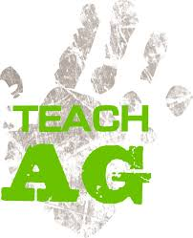

Contact: John Clark
State Teach Ag Results Program - KAAE Rep.
Buhler High School
611 N. Main
Buhler, KS 67522
Phone (620) 543-2255
jclark@usd313.org

For Release: November 18, 2021

2022 Kansas Ag Teacher Job Shadowing Day

Twenty current high school students will earn the opportunity to spend the day with a high school agriculture education teacher other than their own and find out what it’s really like to “Teach Ag”.

ELIGIBILITY: Current Kansas high school agriculture education students/FFA members. Preference will be given to high school juniors and seniors.

DEADLINE: Applications must be e-mailed as an attachment to jclark@usd313.org by Monday, December 15, 2021. Subject line of the e-mail should read “Teach Ag Application”.

CRITERIA: The application should be submitted in a PDF or Word document format and include Student’s Name, Address, Phone #, E-mail and Grade Level; School Name, Address and Phone #; and Advisor’s Name, Phone # and E-mail. In addition, please let us know if you have received a “Teach Ag” t-shirt and if not, please indicate your t-shirt size.

Also, please include a paragraph (250 words or less) explaining why you are interested in becoming an Ag Teacher/FFA Advisor.

Finally, please list up to three (3) agriculture education programs in the state that you would prefer to visit in priority order and explain why.

From the applications received, the top twenty (20) applicants will be selected by mid January. Selected applicants will then be notified by e-mail and given instructions on how to make arrangements for their job shadow day to be completed by the end of the spring semester.

Through financial support from the Kansas Association of Agricultural Educators, each selected participant will receive a $50 stipend once they’ve completed their job shadowing experience and a short survey.

